**Colombia’s Violent Past,**

**Unsteady Present, and**

**Proposed Path Forward**

**with US Policy Changes**

Abstract

Does a path exist beyond the coercive actions taken by the US to help end violence in Columbia?  
This paper explores multiple non-coercive solutions to horrendous violence in Columbia

Michael Moyer

michaelmoyer@g.harvard.edu

**Introduction**

Large scale macro-conflicts and violence have dramatically decreased recently in Colombia. However, more than half a century of a civil war and the rise and subsequent fall of drug trafficking empires left Colombia in a precarious security situation. In this paper I will examine the current conflicts in Colombia, which can be separated into two distinct categories: politically motivated conflicts and organized crime related conflicts. I will also explain the reasoning behind both of these types of conflicts, and I will elaborate on why rampant violence has persisted even after various peace deals and ‘successful’ security operations. Concurrent with the continuation of violence, I will examine the role of the United States in the development of various conflicts. I will show that the United States’ economic and security policies have stoked the flames of many conflicts in Colombia, and the attempts by the United States to minimize the severity of the conflicts has been largely inadequate. Lastly, I will suggest that the United States should take the advice of the RAND Corporation (“the Research And Development Corporation”) and not pursue a coercive security operation in an attempt to suppress the conflicts in Colombia. Instead, I will argue that the United States should reform its drug policy, legalizing much drug usage in the United States itself, and the US should promote competitive industries within Colombia to allow for economic prosperity: creating an environment where violence can be quelled by a more productive path forward.

**Violence Quantified**

First, the homicide rate in Colombia has fallen dramatically in the past decade. According to the United Nations Office on Drug and Crime, Colombia in 2018 has experienced its lowest homicide rate in the last 40 years at around 24 homicides per 100,000 in the population. However, it is important to note that this homicide rate is still one of the highest in the world, and it is almost five times the world average of around 5.3 homicides per 100,000. Below I added the visual representations of these homicide trends:

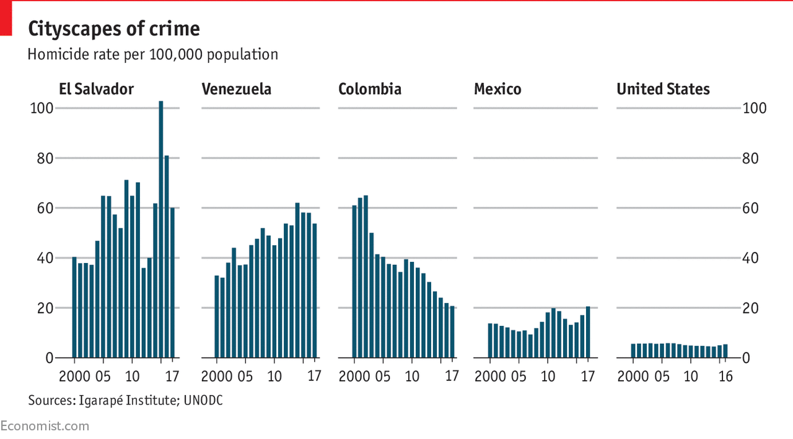[1]

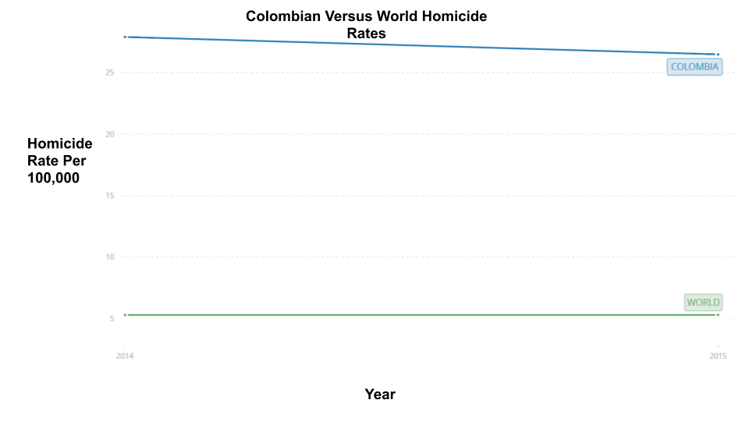[2]

**Politically Motivated Conflicts**

The first types of conflicts which contribute to the horrendous violence are ‘politically motivated conflicts. The conflicts emerged when left wing groups were justifiably distraught with the assassination of the populist, leftist political leader Jorge Eliécer Gaitán in 1948. This led to what is known as La Violencia. The United States strongly backed anti-communist repression in rural Colombia, and liberal and communist groups reorganized into sophisticated militias to fights against such repression. While the reasons for fighting varied widely from group to group, generally FARC, Fuerzas Armadas Revolucionarias de Colombia, and other guerrilla groups state that they are the champions for the poor in Colombia and that they protect the poor from government and paramilitary oppression. The largest of these groups was FARC, and this group only disbanded in 2016 after a peace agreement with the Colombian government.[3] However, some FARC dissidents have refused to lay down their arms even after the peace treaty came into effect, and they are supposed to number around 1,200 current armed combatants.[4] Additionally, the Ejército de Liberación Nacional (the ELN) is a revolutionary group that numbers between 1,380 and 3,000 guerrillas and the Ejército Popular de Liberación (EPL) is a revolutionary group that numbers only around 150.[5]

Recently, FARC dissidents have become an increasing problem for the Colombian armed forces who must concurrently fight the ELN, the EPL and the drug cartels. These fighters, and the right-wing paramilitary groups like the AUC are engaged in both terrorist activities and drug trafficking. Additionally, all of these groups have been criticized for their numerous human rights violations. As the violence continues, it begs the question: what is the culpability of the United States in causing or exacerbating this violence, and what should the United States’ role be in curbing this violence?

**US Involvement**

The United States has been heavily involved in these politically motivated conflicts from their foundations in the early 1960s. It was the US government that encouraged the Colombian military to conduct operations against leftist militants. Within the United States’ high command, attacks against this leftist insurgency were viewed as part of the US fight against Communism. Accordingly, the US sent a Fort Bragg special warfare team in 1962, headed by General William P. Yarborough, to investigate “Colombia’s security situation”.[6] Yarborough then successfully encouraged the Joint Chiefs of Staff to create and deploy paramilitary forces that could commit terrorist and sabotage acts against the leftist insurgency. US involvement does not end there. Multinational corporations, like Chiquita Brands International, allegedly has been directly tied to paramilitary death squads, and resulted in multi-million-dollar settlements with the US Department of Justice.[7] However, just because the US had a role in eradicating leftist militants, was the US in fact contributing to the growth of the conflict?

I think that the United States bears notable responsibility with respect to the growth in the conflict. First, direct, coercive military actions against the leftist insurgencies was extremely unlikely to eradicate the insurgencies. The dense jungles of rural Colombia provided radical militias groups with a perfect terrain advantage to run a guerilla war. Lessons from the Vietnam War had taught some that a dense jungle-based guerilla war, even with the massive military might of the United States, proves ultimately frustrating. Some at the RAND Corporation wrote just this in the 1960s, arguing that the Colombian conflict could not have been won via conventional military tactics.[8] This proved accurate, as five decades had passed using conventional military tactics against the insurgents, yet FARC and the leftist insurgency continued. Thus, it likely would have been a better solution to address the insurgency at the beginning of the conflict by allowing the insurgents a voice in the political system, instead of ruthlessly targeting them. With that said, the United States should not have framed the conflict in the greater context of the Cold War, and they should not have intervened to prevent the political participation of the leftists.

Notwithstanding, since history cannot be changed, what should the United States do to resolve the politically motivated conflicts that still exist in Colombia? This is an extremely complicated question, and the answer involves an understanding of the second conflict persisting in Colombia: organized crime.

**Organized Crime**

Organized crime in Columbia is a historical centerpiece that laid the foundation of influencing political power and of regional economic windfalls in Colombia. Columbia’s organized crime has its roots in the lucrative drug trade from Columbia to the United States. In the 1970s, many poor Colombian farmers began producing marijuana for smuggling into the United States at a far higher selling price than the subsistence living from traditional crops. These remote farmers, who often were isolated in mountainous terrain, took the risks of growing marijuana plants and the Colombian government generally allowed it. The Colombian government likely saw the increased regional profits from the marijuana trade as a boom to the respective local economy. However, pressure from the Drug Enforcement Administration in the United States to adopt international legislation in line with the ‘War on Drugs’ led to the Colombian Law 30 of 1986, known as the Estatuto Nacional de Estupefacientes - ENE, which criminalized drug use.[9]

Moreover, the organizations working the marijuana trade became more concentrated. These more concentrated organizations wanted the revenue from the lucrative businesses of cocaine. Instead of growing the coca leaves themselves, the Colombian drug organizations became experts at processing coca leaves into cocaine and trafficking the finished product to the United States. The 1980s saw the first major drug cartels formed: the Cali Cartel in the south-west of Colombia and Pablo Escobar’s Medellín Cartel.It was not uncommon for politicians, the police, and citizens to work for the cartels, as Colombian citizens debated the good aspects of the drug trade (revenue and jobs for their towns) versus the bad (kidnappings, bribery and murder). The fabric of Colombian society today is a mesh of the conflicts from this time period. Immense drug profits and ruthless tactics still influence political decision-making. Policymakers have learned to fear violent retaliation for policies directed at curbing the business of organized crime, evidenced by more than 300 assassinations of Colombian human rights defenders and social or community leaders from 2016-2018.[10]

Currently, organized crime is dominated by paramilitary-criminal hybrids, which the government has dubbed BACRIM (Bandas Criminales). These organized crime groups “largely consist of paramilitaries that either rearmed or did not demobilize and are led by former mid-level AUC commanders” (Insightcrime, Colombia Profile 2018). The three most successful BACRIM groups are the Rastrojos, the Oficina de Envigado and the Urabeños. While these groups no longer have the sheer prowess that the former cartels had, it is clear that drug consumption, production and trafficking remain a problem in Colombia. In fact, the Colombian drug trade as a whole is estimated to be worth approximately $10 billion each year.[11] Despite the over thirty years of US-led drug control efforts which concentrate their efforts on the criminalization of drug production, consumption and the eradication of drug traffic, consumption and trafficking have remained steady.[12] Thus, should the United States completely forgo any coercive, security centered policy in Colombia in regards to drug usage and production as these policies have, at best, maintained a steady-state equilibrium in both of those regards?

**US Response**

I argue that the United States should completely forgo a coercive, security centered policy in Colombia. It is important to recognize that the US has been culpable in creating an environment of both organized crime conflicts and of politically motivated conflicts in Colombia. As I stated before, it is clear that the US has fueled resentment from leftist insurgent groups by encouraging their exemption from the political process within the Colombian government and by funding paramilitary groups that sought to eradicate the leftist groups completely. The severe drug criminalization policies that the United States forced onto Colombia did not allow for a regulated market, which is a market ripe for exploitation from organized crime groups. Thus, future US policy must recognize the culpability of the United States in fostering these conflicts and, recognizing the past policies initiatives as ineffective, must provide meaningful policy solutions.

The United States must realize that the ‘drug war’ is not one it can fight with bullets, the United States must fight it with dollars. The United States leads the world in illegal drug use.[13] Without dramatically shrinking the demand for a product, the supply will rise up to match the demand, and it is clear that coercive actions against drug production have failed to quell the demand for drugs. In fact, according the National Institute of Drug Abuse, even over the last decade illicit drug use in the United States has been increasing; “In 2013, an estimated 24.6 million Americans aged 12 or older—9.4 percent of the population—had used an illicit drug in the past month. This number is up from 8.3 percent in 2002”. Thus, if the demand for illicit drugs will not go down, why not legalize the market and heavily regulate the drug usage? This would prevent criminal organizations in Colombia from taking advantage of the illicit nature of the drug production. With this legalization in mind, the Colombian people could profit from the production of drugs, creating an environment in which violence is less necessary. Both Switzerland and Portugal represent successful examples of countries that have radically pursued legalization for drug use and production.[14] [15]

Notwithstanding, it is understandable to be worried about the term ‘drug legalization’. Many people when they hear such a phrase imagine drug pushers on the streets selling cocaine to anyone. However, as the ACLU points out: “that is what exists today under prohibition... In the long run, ending prohibition could foster the redirection of public resources toward social development, legitimate economic opportunities and effective treatment, thus enhancing the safety, health and well-being of the entire society."[16] While legalization seems like a drastic change, seemingly allowing for drugs to run rampant through US society, legalization could take the drug problem off the streets in US cities. Legalization allows for a highly regulated market, which allows for taxable revenue for the state. Thus, the legalization argument provides a two-fold benefit. First, it increases revenue in Colombia rather than spending money in Columbia to appease the United States’ failed ‘war on drugs’. Second, and more importantly to Colombia, organized crime barons would no longer be the primary beneficiaries from the illegal drug trade.

Nevertheless, the legalization of currently illicit drugs would only go so far to curb the violence in Colombia. Vast economic inequality in Colombia has created a society of the ‘have’ and ‘have nots’. According to the World Bank: “Colombia was Latin America’s second most unequal country after Brazil in 2017. More than 320 children died of malnutrition in 2017. The country’s three richest men owned more than 10% of the country’s GDP.”[17] Extreme economic inequality results in resentment, conflict and crime, which ultimately produce violence. This is perfectly demonstrated in South Africa, which by several measures is the most economically unequal country in the world. South Africa experiences over 200 violent street robberies a day. In an economically unequal society, marginalized citizens challenge their social exclusion, and they attempt to redistribute wealth by any means necessary. I argue that politically motivated conflicts in Colombia stem from a severely unequal distribution of wealth. This begs the question: can the United States change this inequality?

The simple answer is that the US cannot directly make Colombian society more equal. However, the United States could change how it distributes aid, and the US could change its trade policies regarding Colombia. The United States’ bilateral foreign assistance to Colombia is $391 million per year, and more than 75% of this funding goes to military aid like GPS guidance systems and smart bombs.[18] This funding should be distributed into grass-roots economic development programs. For example, the US can distribute loans for rural businesses through non-profit groups like the Initiatives for Development at negligible interest rates. However, more important than million dollar aid packages to the address the problem of inequality would be a change in trade policy.

Currently, Colombia is being held hostage by neoliberal economics. New research conducted by the IMF (the International Monetary Fund) suggests that the implementation of neoliberal economic policy, “makes individuals more self-interested and concentrates resources in the hands of the few, making competition for resources more intense. The accumulation of wealth in relatively few hands threatens economic fairness, economic dynamism — and democracy.”[19] It is ironic that the IMF would be conducting such research as they are one of the culprits that fosters the neoliberal economy on countries. The complicated story goes as follows:

1. A country like Colombia has a comparative advantage in a good (or product), so the government subsidizes the industry that good is produced within
2. A country wishes to sell that good in the United States and other large consumption hubs
3. The United States either petitions the WTO (the World Trade Organization) that the subsidized good does not provide for fair competition, and tariff walls are imposed, or the United States gets concessions in the form of a bilateral agreement

The problem with accepting a bilateral agreement with the United States is that it often comes with tradeoffs. For example, South Korea made a bilateral agreement with the United States to allow for car manufacturers in Korea to sell their subsidized cars in the US. However, the United States demanded that South Korea opens up its financial system to the US market. The repayment timing difference between the US and South Korea financial markets caused the South Korean economy to crash. In turn, South Korea obtained a conditional loan from the IMF to bail out its corrupted economic system. However, the conditions the IMF demanded included the adoption of neoliberal policies and the prevention of ‘unfair’ government subsidies to South Korean companies. Why does this all matter in the case of Colombia?

This pattern of trade prevents a country like Colombia, that does not have the necessary capital to create an interindustry comparative advantage organically, from providing sufficient subsidies to key industries. Thus, countries like Colombia are often forced to adopt loans with the associated neoliberal economic policies, and its key industries are never fully developed. The United States can change this savage trading regime it has helped create. First, it should allow for more judges from the global south into the WTO so that countries like Colombia can get a fair trial. Second, the US should use its considerable leverage to change the definition of ‘unfair’ trade. Countries like China are exempt from this harsh trading regime, and can freely subsidize key industries, but poorer countries are unable to circumvent the system like China. Lastly, the United States should use its considerable leverage to merge two big issues, trade and finance, together in one organization. Currently, the WTO and the IMF do not coordinate together to make policies. This leads to results like the South Korean case, where separately WTO and the IMF punished Korea.[20]

**Summary**

In conclusion, the conflicts in Colombia, both politically motivated and organized crime related, are not a problem that must persist forever. However, the United States must first recognize its culpability in propagating the two conflicts, and then the US can pursue meaningful new solutions to the conflict. In this paper, I offered two solutions that could replace the current coercive security solution in place. First, I argued that drug use and production should be legalized and heavily regulated in the United States and Colombia. Second, I suggested that the international trade regime set up by the United States must change in order to improve the fundamental economic landscape present in Colombian society. The conflicts in Colombia are not lost causes, but they will require distinctly new collaborative and unilateral efforts from the United States to help resolve these historically based problems.

Word count: 2988

Sources

All my sources have been footnoted. Please visit them for any additional information.

1. Source: Economist.com - United Nation Office on Drug and Crime:

   https://www.economist.com/graphic-detail/2018/04/11/latin-americas-homicide-epidemic
2. Source: The World Bank Intentional homicide rates: https://data.worldbank.org/indicator/vc.ihr.psrc.p5
3. http://www.rebelion.org/noticia.php?id=67904
4. https://www.elpais.com.co/judicial/mas-alla-de-guacho-las-disidencias-siguen-siendo-un-blanco-dificil-para-las-ff-aa.html
5. https://www.semana.com/nacion/articulo/megateo-capo-del-catatumbo/351401-3
6. https://colombiareports.com/causes-colombia-conflict-international-actors/
7. https://colombiareports.com/causes-colombia-conflict-international-actors/
8. Steele, A., & Schubiger, L. I. (2018). Democracy and civil war: The case of Colombia. *Conflict Management and Peace Science*, *35*(6), 587–600. <https://doi.org/10.1177/0738894218787780>
9. http://www.druglawreform.info/en/site_content/item/203-colombia
10. https://anfenglishmobile.com/features/colombia-un-security-council-optimistic-despite-assassinations-30356
11. https://www.businessinsider.com/colombias-drug-backed-economy-2011-4
12. https://foreignpolicy.com/2014/06/13/colombia-calls-a-draw-in-the-war-on-drugs/
13. https://www.cbsnews.com/news/us-leads-the-world-in-illegal-drug-use/
14. https://www.reuters.com/article/us-swiss-drugs/swiss-drug-policy-should-serve-as-model-experts-idUSTRE69O3VI20101025
15. https://www.theguardian.com/news/2017/dec/05/portugals-radical-drugs-policy-is-working-why-hasnt-the-world-copied-it
16. https://aclu.procon.org/view.source.php?sourceID=001737
17. https://data.colombiareports.com/colombia-poverty-inequality-statistics/
18. https://colombiareports.com/us-will-again-give-391m-in-aid-to-colombia-despite-trump-effort-at-cuts/
19. https://www.kpsrl.org/blog/the-injustice-of-inequality-and-its-links-to-violence
20. http://factsanddetails.com/asian/cat62/sub408/item2558.html